­­­­­­­­INSTITUTE OF COMPUTER TECHNOLOGY

B-TECH COMPUTER SCIENCE ENGINEERING 2025-26

SUBJECT:COMPUTER NETWORKS

NAME: Rahul Prajapati

ENRLL. NO: 23162171020

BRANCH: CYBER SECURITY

BATCH: 52

**PRACTICAL_10**

**Aim:** To design a network using EIGRP ( Enhanced Interior Gateway Routing Protocol ).

1. **NETWORK DESIGN:**

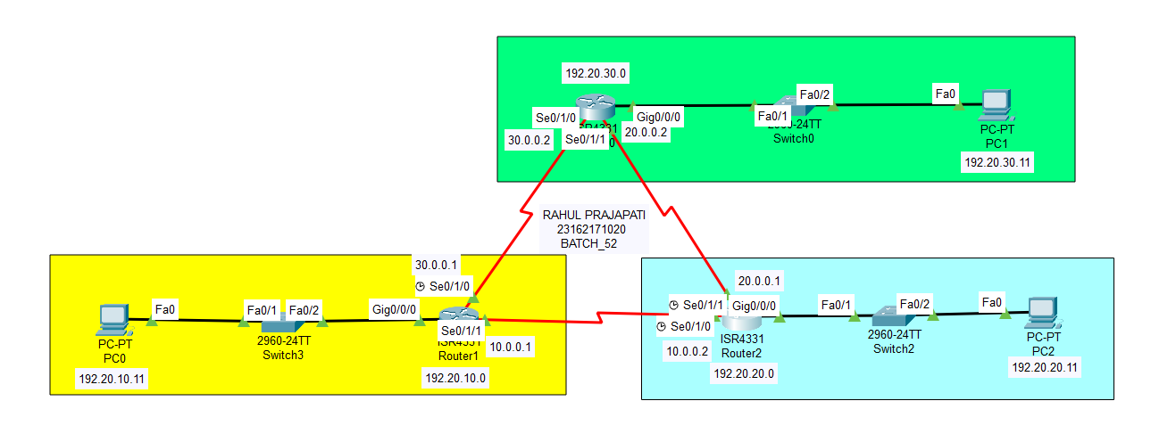

1. PCs_IP:

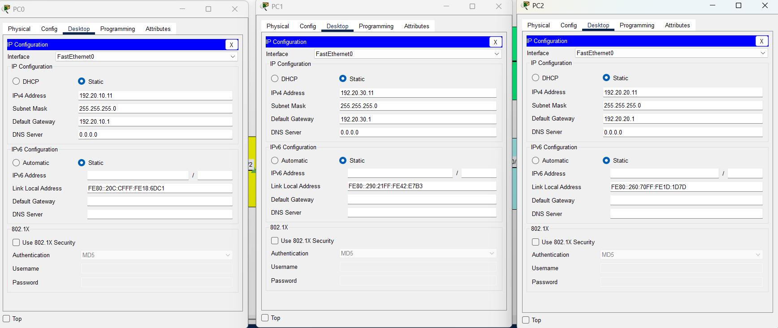

1. ROUTERs_IP_CONFIGURATION:







1. **IP_ROUTE & CONFIGURATION :**
   1. **ROUTEs_1**

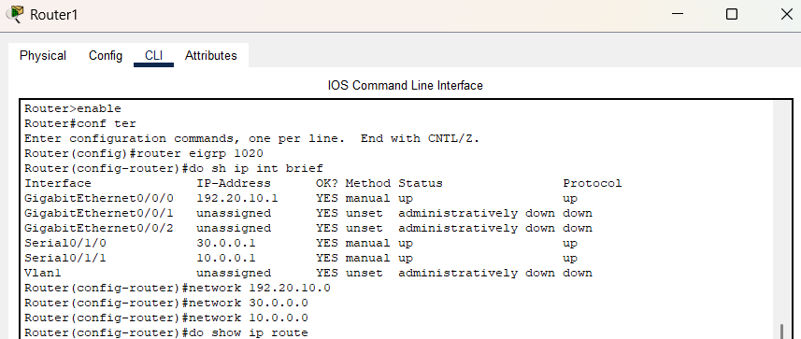

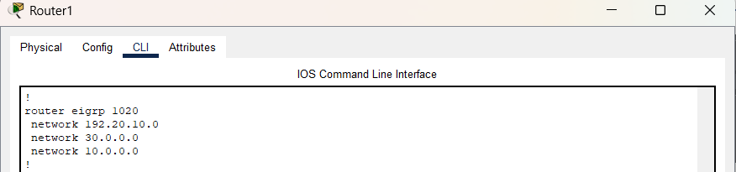

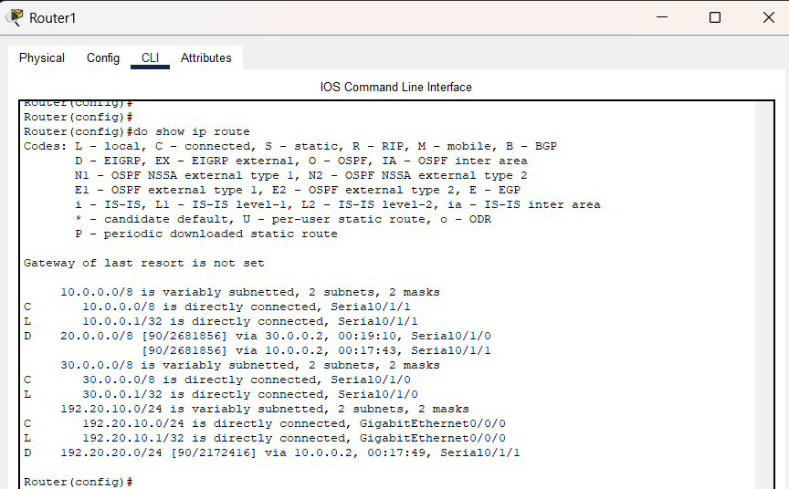

1. **ROUTER_0:**

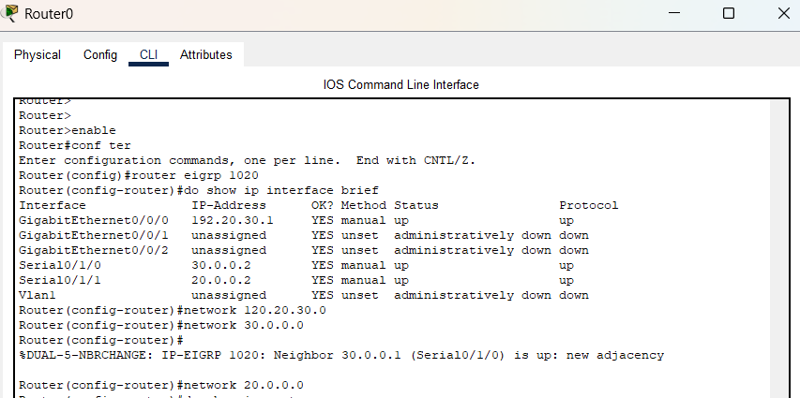

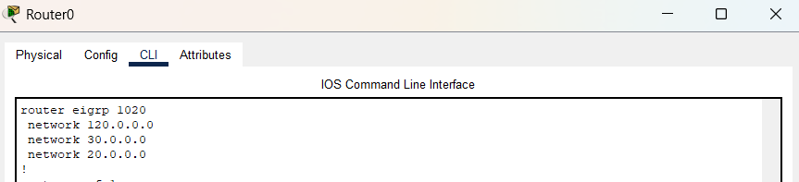

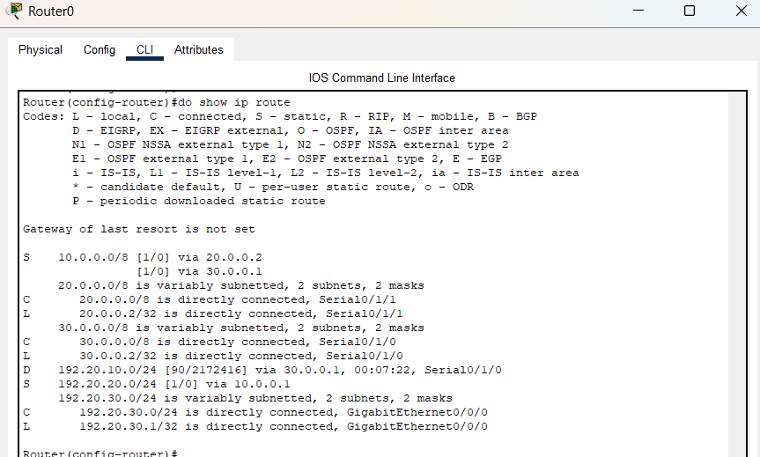

1. **ROUTER_2:**

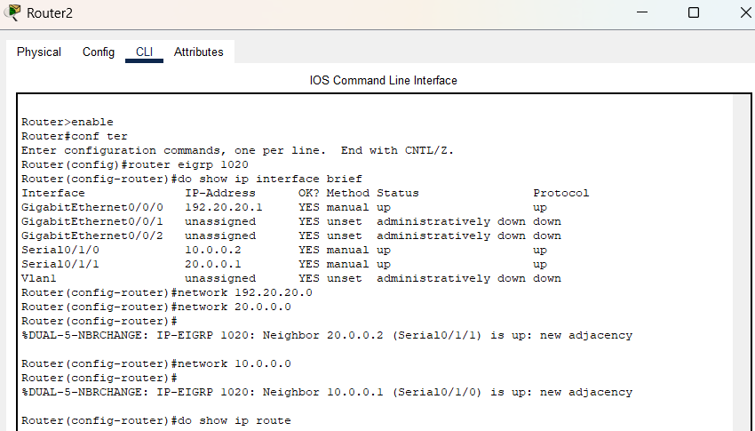

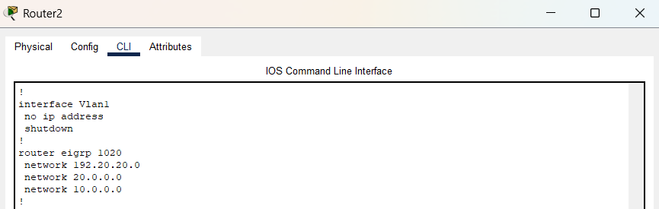

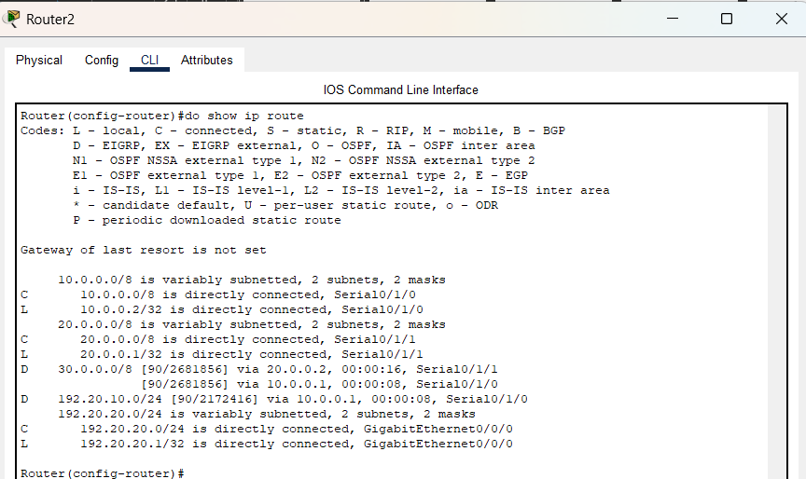

**Conclusion:**  
EIGRP was successfully configured. After assigning IP addresses and enabling EIGRP on all routers, they exchanged routing information within the same autonomous system. This verified that EIGRP provides fast convergence, efficient route calculation, and stable communication across the internal network.